Smart Attendance System using Facial Recognition

T.Shiva Sharan (160722735077), P.Abhilash (160722735086), CH,Manideep (160722735084)
Project Guide : Mr.T.Anil Kumar, B7
Pragyatmika Centre of Excellence
Department of Electronics and Communication Engineering
Methodist College of Engineering and Technology, Hyderabad, India
Emails: shivasharan824@gmail.com, andrewawaken3@gmail.com, manideepchiluka8@gmail.com

Abstract:

Traditional methods of marking attendance are often inefficient, time-consuming, and susceptible to proxy attendance. This paper presents a comprehensive framework for an intelligent, automated attendance system leveraging facial recognition technology. The proposed system architecture integrates embedded systems for image acquisition and edge processing, deep learning models for accurate face identification, and Internet of Things (IoT) capabilities for seamless data logging and management. By reviewing existing methodologies, from classical computer vision approaches using OpenCV to modern deep learning techniques involving Convolutional Neural Networks (CNNs), this paper outlines the design considerations for developing a robust, scalable, and secure smart attendance solution. The framework addresses key components including data acquisition, face detection, feature extraction, recognition, and secure data handling, providing a blueprint for implementation in academic and corporate environments.
- INTRODUCTION
Manual attendance marking in educational institutions and organizations is a process laden with inefficiencies. It consumes valuable time, is prone to human error, and can be compromised through fraudulent practices like proxy attendance. The evolution of biometric technology offers a robust alternative, with facial recognition emerging as a leading solution due to its contactless nature and high accuracy.
Recent advancements in Artificial Intelligence (AI) and the proliferation of low-cost embedded computing hardware have made the development of smart attendance systems more accessible and effective. These systems can autonomously identify individuals and log their attendance in real-time, significantly improving efficiency and data integrity. Furthermore, the integration of Internet of Things (IoT) technology provides a framework for centralized data management and remote accessibility, making the entire process transparent and streamlined.

This paper reviews the progression of facial recognition attendance systems and proposes a generalized, intelligent framework. We examine various approaches, from foundational systems using OpenCV to advanced implementations that utilize deep learning methods like Convolutional Neural Networks (CNNs) for superior performance. The proposed framework aims to serve as a guide for developing a secure, efficient, and scalable smart attendance solution.
- LITERATURE REVIEW
The domain of automated attendance has seen significant evolution. Early systems often relied on technologies like RFID, which, while an improvement over manual methods, were still vulnerable to proxying. The shift towards biometrics marked a significant step forward.
A. Traditional and OpenCV-Based Approaches
Initial forays into facial recognition for attendance often utilized classical computer vision libraries, most notably OpenCV. These systems typically employed algorithms like Haar Cascades for face detection and methods like Local Binary Patterns Histograms (LBPH) for recognition. While functional, their performance could be limited by variations in lighting, pose, and expression.
B. Advancements with Deep Learning
The advent of deep learning revolutionized the field of computer vision and, by extension, facial recognition. Models based on Convolutional Neural Networks (CNNs) have demonstrated vastly superior accuracy in recognizing faces under challenging conditions. These deep learning methods are now central to modern educational attendance systems. Various studies have conducted comparative analyses of different recognition models to determine the most effective architectures for smart attendance applications.
C. System Integration and Architecture
Modern systems are not just about the recognition algorithm; they are complex integrations of hardware and software. Many recent projects are built on embedded platforms like the Raspberry Pi, enabling cost-effective, standalone devices. The integration with IoT provides a robust backend for data synchronization and management, creating a complete framework from image capture to report generation. To enhance security, some systems propose multi-factor authentication, combining facial recognition with a One-Time Password (OTP) to ensure user presence and prevent spoofing attacks. The scope also extends to monitoring groups of people simultaneously.

III. METHODOLOGY
The system operates through a sequence of steps, from initial setup to final data logging. The core process involves capturing an image, recognizing the individual, and recording their attendance automatically.
Initial Setup and User Enrollment :
- System Initialization: The ESP32-CAM module is powered on and connects to a pre-configured Wi-Fi network. The necessary code, developed using the Arduino IDE, is flashed onto the ESP32-CAM using an FTDI programmer.
- Face Registration: An administrator is responsible for enrolling users by registering their faces into the system's database. This creates a baseline of known individuals for future recognition.
Image Capture and Processing:
- Image Acquisition: The ESP32-CAM's built-in camera captures images of the area in front of it in real-time.
- Face Detection and Recognition: The captured image is processed to detect any human faces. The system then uses the OpenCV library to compare the detected face against the database of registered faces.
Attendance Logging and Data Storage :
- Verification and Marking: If a detected face matches a registered user in the database, the system verifies their identity. Attendance is then automatically marked with the current date and a timestamp. If no match is found, the system returns to the capture state.
- Data Storage: The attendance record is saved either locally on a MicroSD card inserted into the ESP32-CAM module or transmitted to a cloud-based storage service for easy access and management
User Interface and Monitoring :
- Real-time Access: Users and administrators can view the live camera feed and access the logged attendance records through a web browser interface. This allows for real-time monitoring and easy retrieval of attendance data.

IV. RESULTS
- Successful Face Recognition: When a registered person comes in front of the camera, their face is detected and correctly matched with the one stored in the database.
- Automated Attendance Marking: Upon successful recognition, the system automatically records the individual's attendance along with a specific date and timestamp.
- Data Logging: The recorded attendance data is successfully saved, either locally to the MicroSD card or sent to a cloud service for storage.
- Live Monitoring: A user is able to view the live video feed from the ESP32-CAM and check the logged attendance records through a web browser interface.
- Handling of Unrecognized Faces: If an unrecognized face is detected, the system does not mark any attendance and continues the process of capturing and recognizing faces
V. DISCUSSION:
The proposed system offers significant advantages over conventional techniques. Manual attendance is inherently slow and susceptible to human error and fraudulent entries like proxy attendance. Physical systems, such as those using paper or RFID cards, are not only prone to manipulation but also require physical contact, a key concern in modern health-conscious environments. This facial recognition system directly addresses these shortcomings by providing a fully automated, touchless, and secure process that enhances both accuracy and hygiene.
Advantages:
- Contactless and Hygienic: By using facial recognition, the system eliminates the need for physical contact with cards or scanners, reducing the spread of germs.
- Fast and Automatic: Attendance is marked automatically and instantly upon face recognition, saving time and removing the need for manual effort.
- Accurate and Secure: The system provides accurate identification of individuals, which minimizes errors and prevents fraudulent practices like proxy attendance.
- Cost-Effective: It is built using affordable hardware like the ESP32-CAM, making it a budget-friendly solution for various organizations.
- Real-Time Monitoring: The system allows for real--time monitoring with instant data logging, and users can easily access attendance records through a web-based interface.
- Scalable: It can be easily adapted and scaled for different environments, including schools, offices, and large-scale events.
VI . ROLE OF COMPONENTS
ESP32-CAM Module
The ESP32-CAM is the central processing unit of the project. This microcontroller is responsible for:
- Capturing images using its built-in camera.
- Processing the facial recognition logic.
- Connecting to the internet via its onboard Wi-Fi to transmit data.
OpenCV (Python)
OpenCV is the core software library that performs the facial recognition task. It processes the images captured by the ESP32-CAM, compares detected faces against a database of registered users, and confirms a person's identity
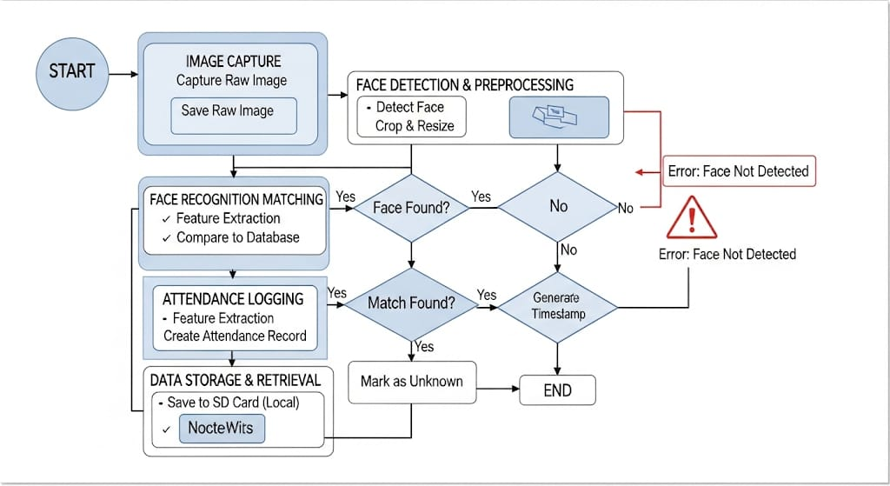

Arduino IDE
The Arduino Integrated Development Environment (IDE) is the software platform used to write and upload the program that runs on the ESP32-CAM. An FTDI programmer is used to flash this code from the IDE onto the module
Wi-Fi Network and Web Browser
The Wi-Fi network acts as the communication backbone, allowing the ESP32-CAM to send attendance data to the cloud and stream video.
The Web Browser serves as the user interface, allowing administrators to view the live camera feed and access the logged attendance records.

CSV File Storage
The attendance data, including names, dates, and timestamps, is organized and written to a CSV file on the card. This format is used because it is lightweight and universally compatible. The resulting CSV sheet can be easily opened and managed in any spreadsheet software, such as Microsoft Excel or Google Sheets, for review and analysis.
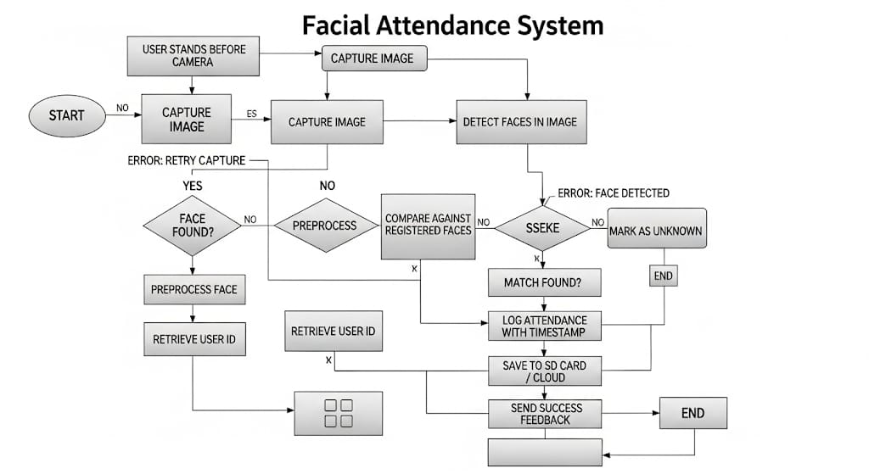

VII. BENEFITS OF THE SYSTEM
The Smart Attendance System offers several practical benefits for organizations by improving efficiency, security, and convenience.
Increased Efficiency and Accuracy
The system's primary benefit is the automation of the attendance process. It provides fast, automatic attendance marking without manual effort, which saves valuable time for instructors and administrators. By removing manual data entry, the system minimizes errors, ensuring that attendance records are accurate and reliable.
Enhanced Security and Hygiene
Facial recognition provides a secure method of identification that prevents fraudulent attendance, such as "buddy punching" or proxy attendance. Furthermore, the system is contactless and hygienic, eliminating the need for shared surfaces like fingerprint scanners or sign-in sheets. This reduces physical interaction and promotes a healthier environment.
Cost-Effectiveness and Scalability
By using affordable hardware like the ESP32-CAM, the system is a cost-effective solution for organizations of all sizes. It is also highly scalable, meaning it can be implemented in a single classroom or across an entire corporate campus with multiple entry points.
Real-Time Monitoring and Convenience
The system offers real-time monitoring with instant data logging. Administrators can easily access up-to-date attendance records through a simple web-based interface, adding a layer of convenience for management and record-keeping.
VI. CONCLUSION
The face recognition-based attendance system using the ESP32-CAM offers an efficient, accurate, and contactless solution for managing attendance. By combining AI-powered facial recognition with IoT technology, the system successfully automates the entire process, which reduces errors and saves a significant amount of time.
The system is both cost-effective and scalable, making it a suitable solution for a wide range of environments, including educational institutions, offices, and secure areas. Overall, this project demonstrates how smart technologies can be applied to improve everyday tasks, enhancing both convenience and security in attendance tracking.
REFERENCES
[1] P. Kumar, A. Singh, and R. Sharma, “Smart attendance system using OPENCV based on facial recognition,” International Journal of Engineering Research & Technology (IJERT), 2020.
[2] S. Jain and V. Gupta, “A comparative study of face recognition models for smart attendance,” International Journal for Research in Applied Science & Engineering Technology (IJRASET), 2023.
[3] A. Verma, "Smart attendance management system using face recognition," International Journal of Scientific Research in Engineering and Management (IJSREM), 2024.
[4] J. Chen and L. Wang, "Internet of things-based intelligent attendance system: framework & practice," MDPI Electronics, vol. 11, no. 7, 2022.
[5] R. Patel and N. Shah, "Smart attendance system (multi-factor authentication with face + OTP)," International Journal for Research in Applied Science & Engineering Technology (IJRASET), 2024.
[6] M. Hasan, "Embedded intelligent attendance monitoring system (Raspberry Pi + face recognition)," 2024, arXiv:2401.0875. [Online]. Available: https://arxiv.org/abs/2401.0875
[7] Y. Liu, "Biometrics recognition using deep learning: a survey," 2019, arXiv:1912.0027. [Online]. Available: https://arxiv.org/abs/1912.0027
[8] S. Ghosh, "Smart attendance system using CNN," 2020, arXiv:2010.0321. [Online]. Available: https://arxiv.org/abs/2010.0321

[9] O. I. Oseni, F. M. Olayanju, A. A. Adetunmbi, and V. O. Matthews, “An Enhanced Real-Time Students’ Attendance Management System Using Facial Recognition,” IEEE Access, vol. 10, pp. 69658-69671, 2022.
https://doi.org/10.1109/ACCESS.2022.3187126
[10] S. S. H. K. Eng, S. F. Toha, A. H. A. Razak, N. M. N. Ayub, and M. K. M. Nor, “Face Recognition for Smart Attendance System in a Cloud-Based Environment,” in 2021 IEEE 11th IEEE Symposium on Computer Applications & Industrial Electronics (ISCAIE), 2021. https://doi.org/10.1109/ISCAIE52203.2021.9431818

[11] S. D. Narduzzi et al., “An Open Source Platform for Smart Attendance Management based on Face Recognition,” in 2020 IEEE International Workshop on Metrology for Industry 4.0 & IoT, 2020.
https://doi.org/10.1109/MetroInd4.0IoT48571.2020.9138243

[12] H. A. Setiadi, W. A. Kusuma, and D. P. R. Asmedi, “Smart Attendance System Based on Face Recognition,” in 2021 3rd International Conference on Cybernetics and Intelligent Systems (ICORIS), 2021.
https://doi.org/10.1109/ICORIS52787.2021.9649567

